

**Communicating System**

**GROUP MEMBERS**

**HUSSAIN AHMED**

**Student1405422**

**OKASHA PEERZADA**

**Student1407720**

**SYED MUDASSIR SHAH**

**Student1363543**

**RAFIA NAJAM**

**Student1385888**

CURRICULUM:

**7062**

BATCH:

**2208E2**

FACULTY:

**MS. NEELAM MALIK**

CO-ORDINATOR:

**MS. WAJEEHA**

**HOME**

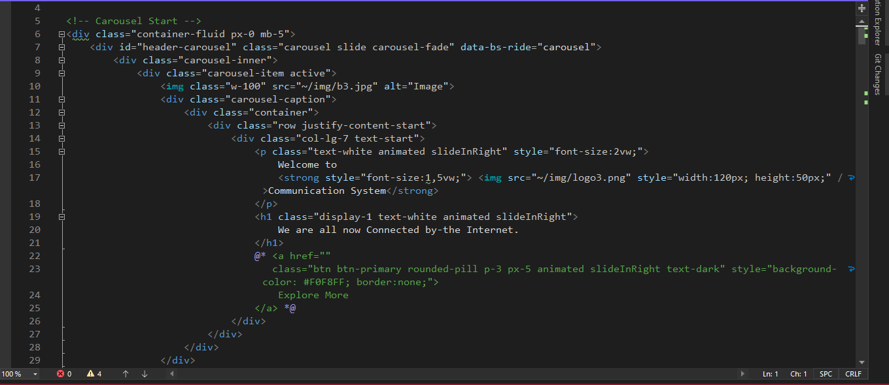

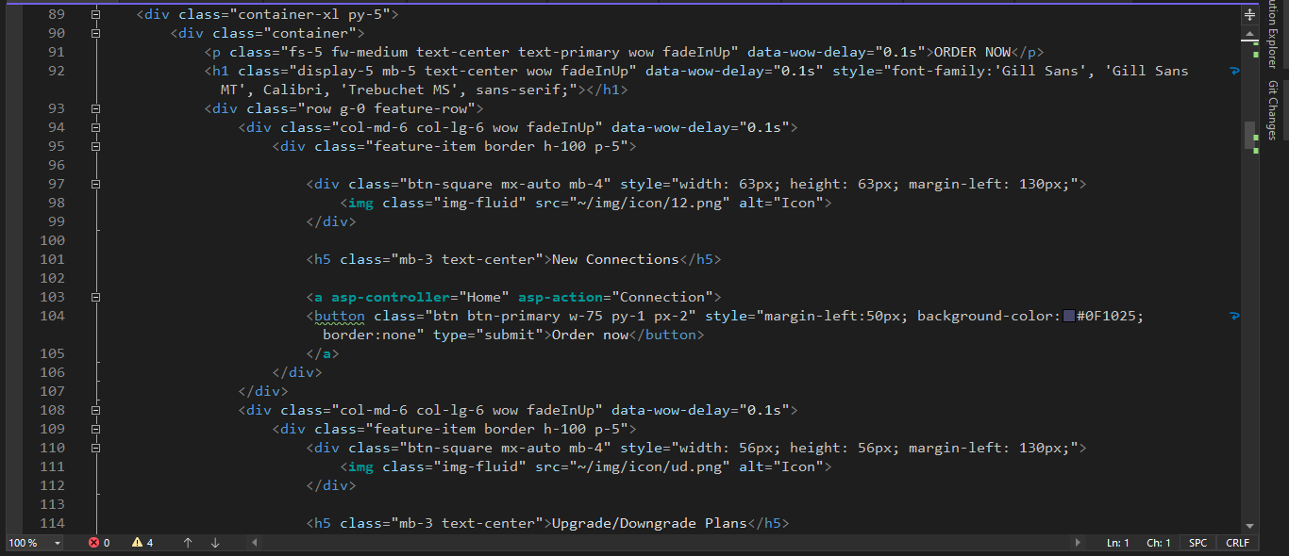

**ABOUT**

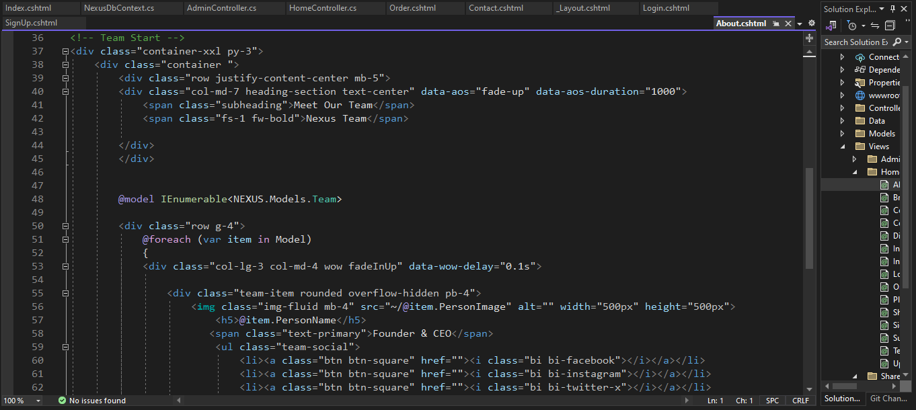

**CONTACT**

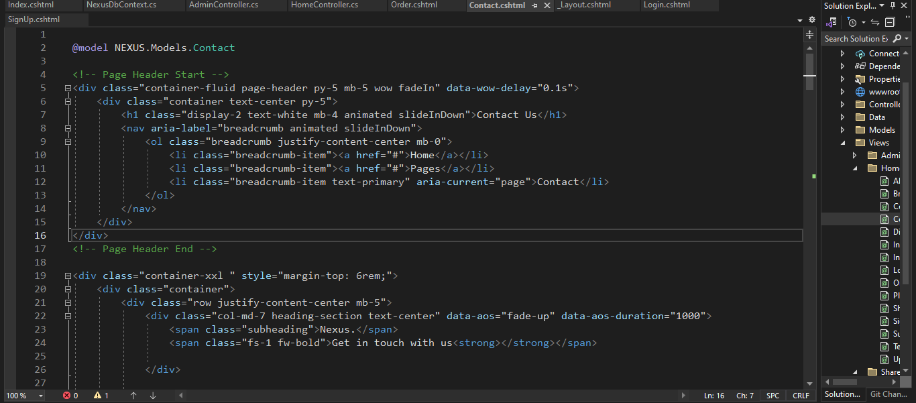

**EQUIPMENT**

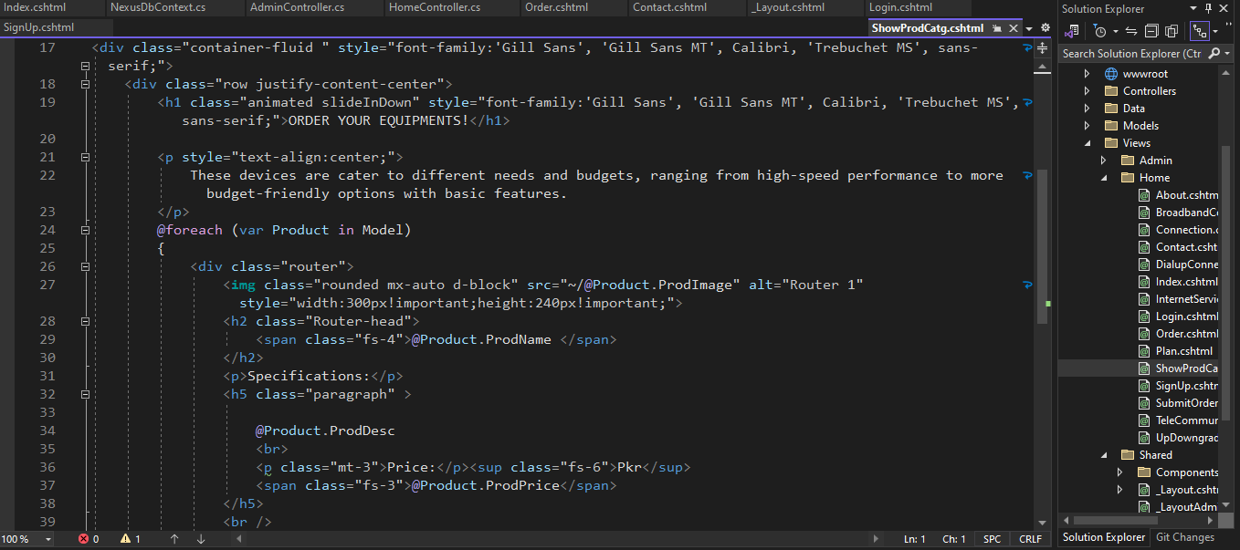

**ADMIN**

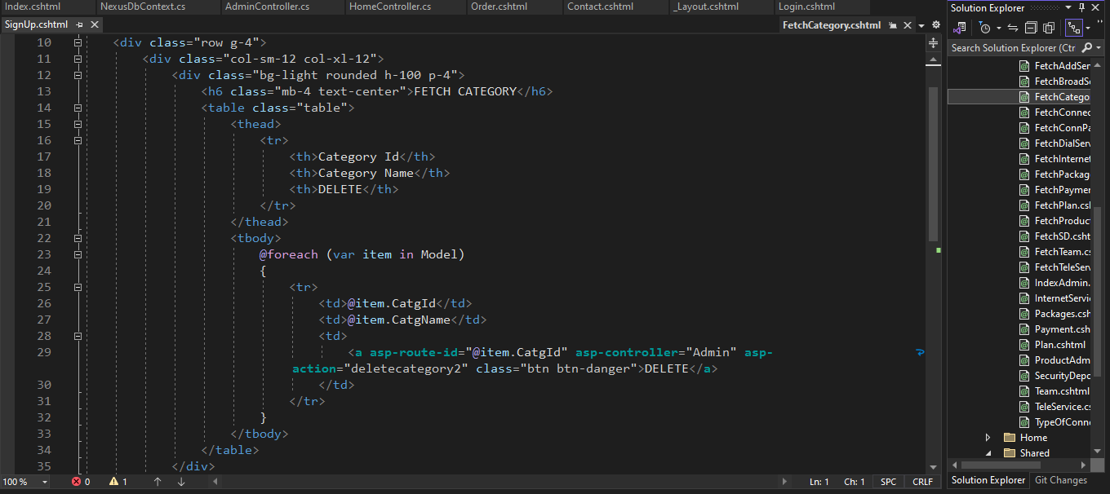

**SIGN UP**

